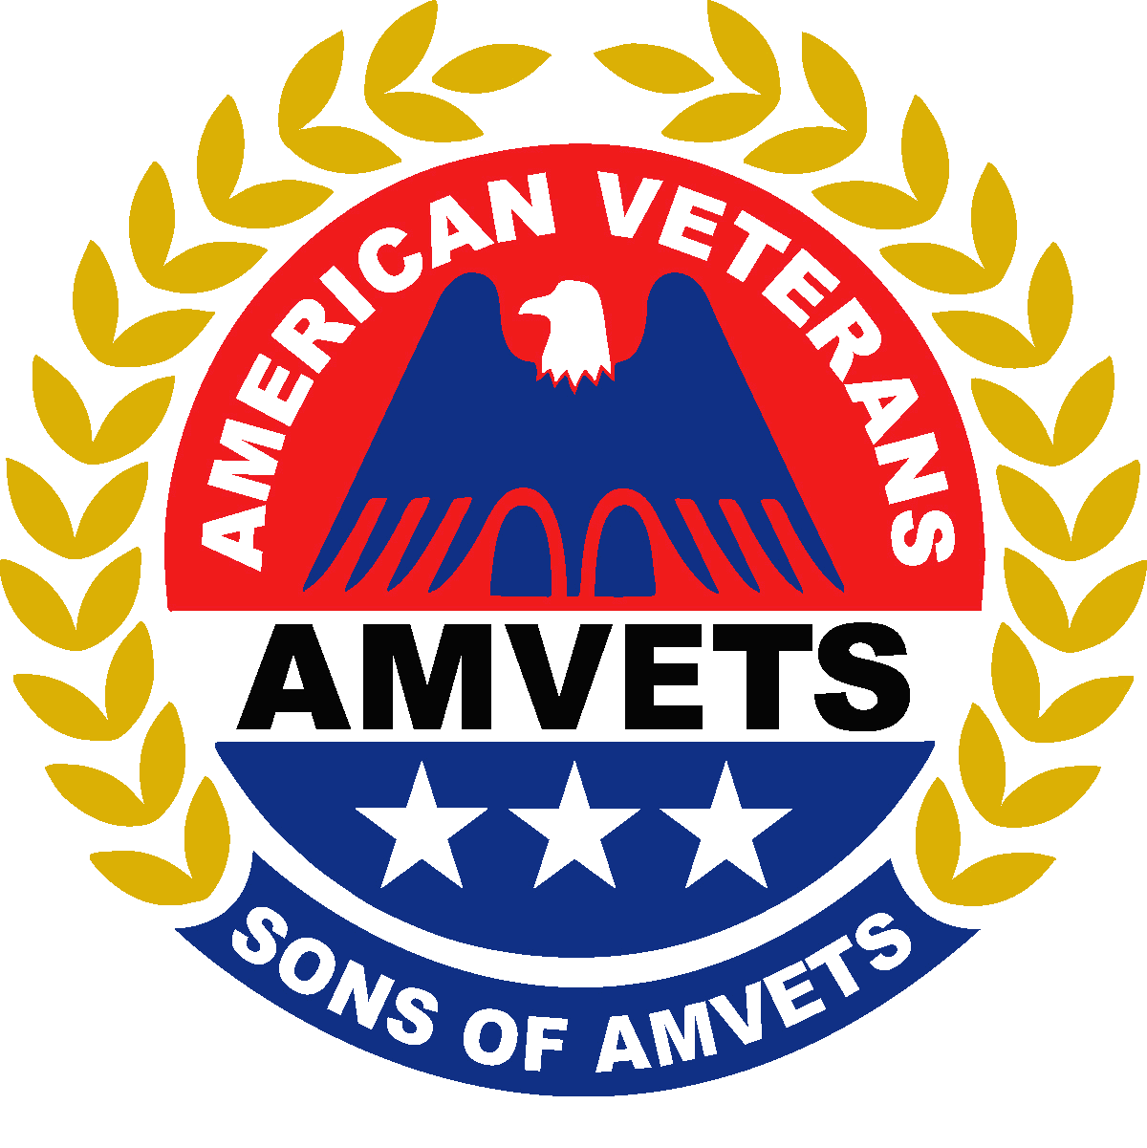
AGENDA

Sons of AMVETS

Fall Conference

October 17-19, 2025

Marriott Columbus NW
5605 Blazer Pkwy
Dublin, OH 433017 Phone: 614-791-1000
All Meetings at the Marriott Columbus NW will be held in the Ball Rooms 1 & 2
Unless otherwise noted

Friday 10/17/2025
5:00 PM – 11:00 PM Hospitality in Ball Rooms 1 & 2
6:00 PM - 7:00 PM Registration (AMVETS Registration Room)
7:30 PM Sons E-Board Meeting (location TBD)

Saturday 10/18/2025
10:00 AM Workshop for membership
11:00 AM Workshop for Project Reports
12:00 PM - 12:45 PM Registration (AMVETS Registration Room)
1:00 PM – 3:00PM Business Session #1
3:15 PM – 3:30 PM PDC Committee Meeting
5:00 PM – 11:00 PM Hospitality in Ball Rooms 1 & 2

Sunday 10/19/2025
8:00 AM – 8:30 AM Registration (AMVETS Registration Room)
9:00 AM Business Session #2

Note: It is important that members are up-to-date on Sons’ business and also have a venue to have questions answered. Therefore, please plan to have at least one representative of your Squadron scheduled to attend both business sessions. Thank you.

AGENDA SUBJECT TO CHANGE AS NEEDED

