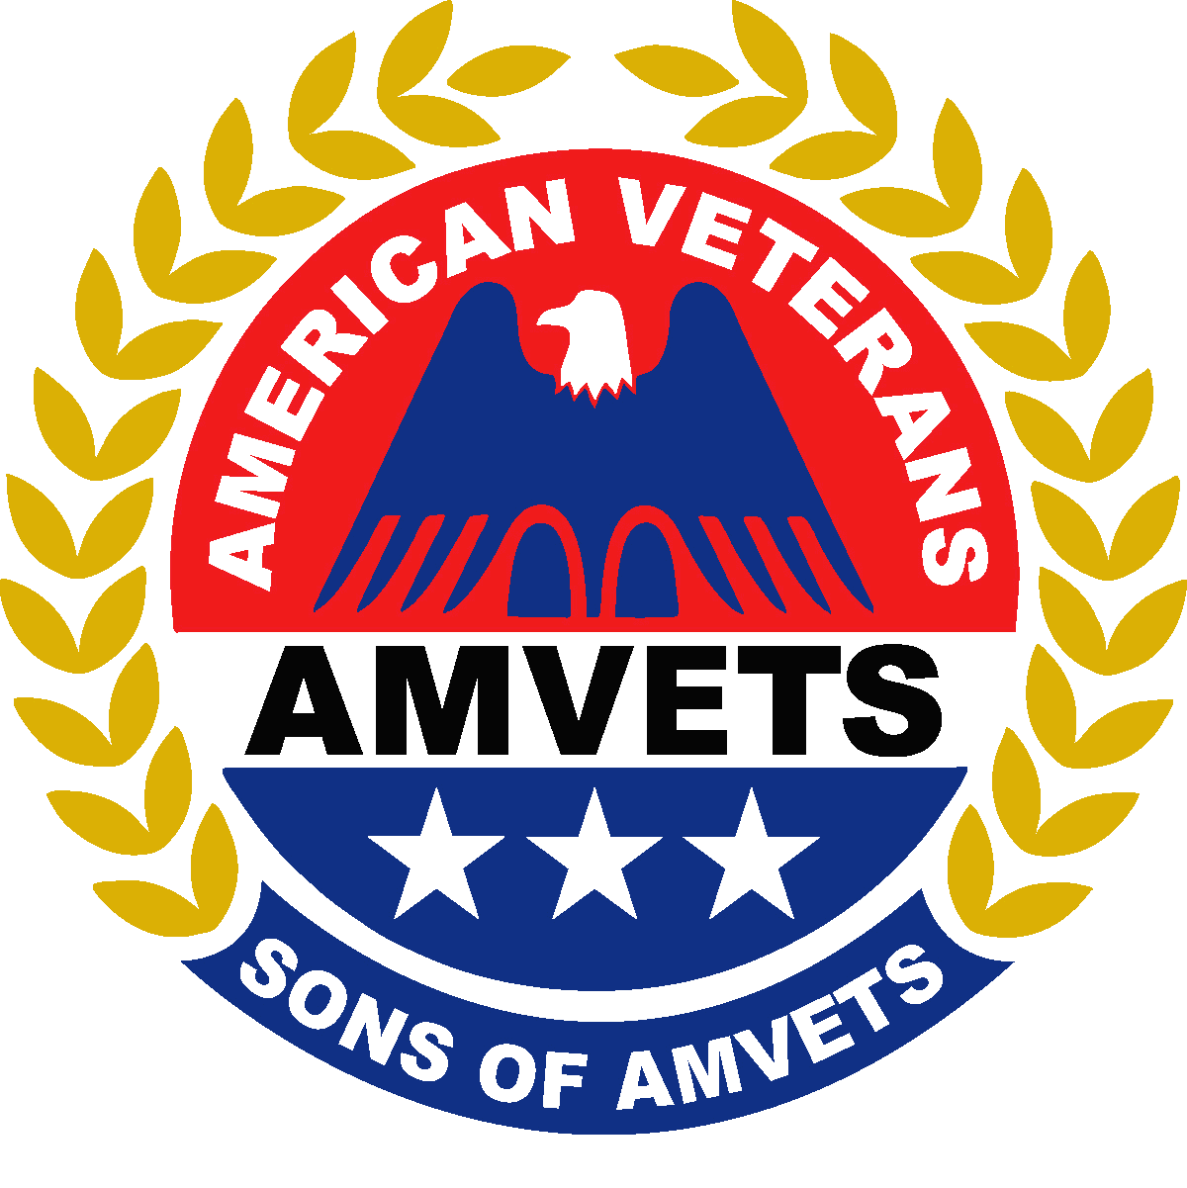
AGENDA

Sons of AMVETS
Fall Conference
October 2-4, 2015

Holiday Inn Westlake
1100 Crocker Road
Westlake, Ohio 44145
440-871-6000
All Meetings in the Holiday Inn will be on
The Conference Level 3rd Floor - Rooms C & D
Unless otherwise noted

Friday 10/02/15
7:00 - 8:00 PM Registration - Conference Level Rooms C & D
8:15 PM Executive Board meeting

Saturday 10/03/15
10:00 AM Officer’s Workshop
11:00 AM Executive Committee Meeting
12:00 PM – 1:00 PM Registration – Rooms C & D
1:00 PM General Membership Meeting 1st Session
2:45 PM Wade Park VA Visit-----Meet in Lobby
4:30 PM Reception for National Auxiliary President
(All Dept Officers asked to attend, in uniform)

Sunday 10/04/15
8:30 – 8:45 AM Registration Rooms C & D
9:00 AM General Membership Meeting 2nd Session

Note: It is important that members are up-to-date on Sons’ business and also have a venue to have questions answered. Therefore, please plan to have at least one representative of your Squadron scheduled to attend both business sessions. Thank you.

AGENDA SUBJECT TO CHANGE AS NEEDED

